GAYATRI VIDYA PARISHAD COLLEGE OF ENGINEERING FOR WOMEN
(Autonomous)
(Approved by AICTE, New Delhi and Permanently Affiliated to Andhra University, Visakhapatnam) Madhurawada :: Visakhapatnam – 530 048
Department of Computer Science and Engineering(AI &ML)

2025 – 2026

To manage recipes including ingredients, instructions, and nutritional information

A REPORT SUBMITTED
BY
Team – 11

NAME ROLL NUMBER

- NEHA SREE 325103282120
N. HAMSIKA 325103282113
SWATHI 325103282101
JHANSI 325103282108

Under the esteemed guidance of Mrs. Y.A.V. Lakshmi Prasanna Assistant Professor
CSE Department

Department of Computer Science and Engineering
GAYATRI VIDYA PARISHAD COLLEGE OF ENGINEERING FOR WOMEN
(Autonomous)
Approved by AICTE NEW DELHI, Affiliated to Andhra University,
Accredited by National Board of Accreditation (NBA) for B.Tech. CSE, ECE & IT - valid from 2019 - 22 and 2022 - 25 Accredited by National Assessment and Accreditation Council (NAAC) with A Grade - valid from 2025 - 2029 Kommadi, Madhurawada, Visakhapatnam – 530048
2025 - 2026

GAYATRI VIDYA PARISHAD COLLEGE OF ENGINEERING FOR WOMEN
(Autonomous)
(Approved by AICTE, New Delhi and Permanently Affiliated to Andhra University, Visakhapatnam) Madhurawada :: Visakhapatnam – 530 048
Department of Computer Science and Engineering(AI &ML)

2025 - 2026

This is to certify that the application report titled “ To manage recipes including ingredients, instructions, and nutritional information”. is a bonafide work of following I B. Tech I Semester students in the Department of Computer Science and Engineering(AI &ML), Gayatri Vidya Parishad College of Engineering for women(Autonomous) during the academic year 2025-2026
S.NO | NAME | ROLL NUMBER
1 | P. NEHA SREE | 325103282120
2 | N. HAMSIKA | 325103282113
3 | SWATHI | 325103282101
4 | JHANSI | 325103282108

Signature of the Guide Signature of the External Mrs. Y.A.V. Lakshmi Prasanna
Assistant Professor Department of CSE

HOD
CSE Department

GAYATRI VIDYA PARISHAD COLLEGE OF ENGINEERING FOR WOMEN
(Autonomous)
(Approved by AICTE, New Delhi and Permanently Affiliated to Andhra University, Visakhapatnam) Madhurawada :: Visakhapatnam – 530 048
Department of Computer Science and Engineering (AI &ML)

INDEX
S.No. | Title | Page No.
1 | Abstract | 4
2 | Introduction | 4
3 | Required Analysis | 4
3.1 | Aim | 4
3.2 | Problem Statement | 4
3.3 | Objectives of the Application | 4
4 | Algorithm | 5
5 | Flowchart | 6
6 | Implementation | 6
6.1 | Source code | 6-11
7 | Output Screen | 12-13
8 | Conclusion | 14
9 | Future Scope | 14
10 | References | 14

1.ABSTRACT

This project is a Python-based Recipe Management System that helps users create and organize recipes using object-oriented programming. It allows users to store recipe details such as title, servings, cooking time, ingredients with quantities and units, and step-by-step instructions. The system also calculates total and per-serving nutritional values (calories, protein, fat, and carbohydrates) for each recipe. Core classes (Ingredient, Recipe, and Recipe Manager) ensure clean, modular design and make the program easy to understand, use, and extend.

2.INTRODUCTION

In everyday life, recipes are often scattered across notebooks, chats, photos, and websites, making them difficult to manage and reuse effectively. This creates problems when users want to quickly find a recipe, check its ingredients, or understand its nutritional value. To address this issue, this project develops a simple Recipe Management System using Python and object-oriented programming. The system provides a unified place to create and manage recipes by capturing essential details such as ingredients, instructions, and servings, while also calculating basic nutritional information. By organizing recipes through well-defined classes and an easy text-based menu, the project aims to demonstrate how programming can solve a real-life problem in a clear and educational way.

3. REQUIRED ANALYSIS
3.1 AIM
To demonstrate a python code to create a program to manage recipes, including ingredients, instructions, and nutritional information.

3.2 PROBLEM STATEMENT
Manual recipe management can lead to confusion, forgotten ingredients, and poor nutritional tracking. There is a need for a digital solution that:
- Stores recipe details (title, servings, cooking time)
- Maintains ingredient lists with quantities and units
- Tracks step-by-step cooking instructions
- Calculates total and per-serving nutritional information (calories, protein, fat, carbs)
- Provides easy recipe management (add, search, view, delete)

3.3 Objectives of the Application
- To add recipes with title, servings, and cooking time
- To manage ingredient lists with quantities, units, and nutritional values
- To track step-by-step cooking instructions
- To calculate total and per-serving nutritional information (calories, protein, fat, carbs)
- To display complete recipe details with nutrition
- To simplify recipe planning and management

4.ALGORITHM
Initialize Recipe Manager (empty recipe list)
- Display menu options:
  - Add new recipe
  - List all recipes
  - View recipe details + nutrition
  - Search recipe by title
  - Delete recipe
  - Exit
- Take user choice
- If choice = Add new recipe:
  - Input recipe title, servings, and cooking time
  - Create Recipe object
  - Input ingredients (name, quantity, unit, calories, protein, fat, carbs) until "done"
  - Add each ingredient to recipe
  - Input instruction steps until "done"
  - Add instruction steps to recipe
  - Store recipe in RecipeManager
- If choice = List all recipes:
  - Display all recipe titles
- If choice = View recipe details + nutrition:
  - Input recipe title
  - Find recipe in RecipeManager
  - If found, display recipe details with ingredients, instructions, and nutrition (total and per serving)
  - If not found, display error message
- If choice = Search recipe by title:
  - Input recipe title
  - Find recipe in RecipeManager
  - If found, display recipe details with nutrition
  - If not found, display error message
- If choice = Delete recipe:
  - Input recipe title
  - Remove recipe from RecipeManager
  - Display success or error message
- If choice = Exit:
  - Display goodbye message
  - Stop program
- Repeat until user exits
- Stop

5.FLOWCHART

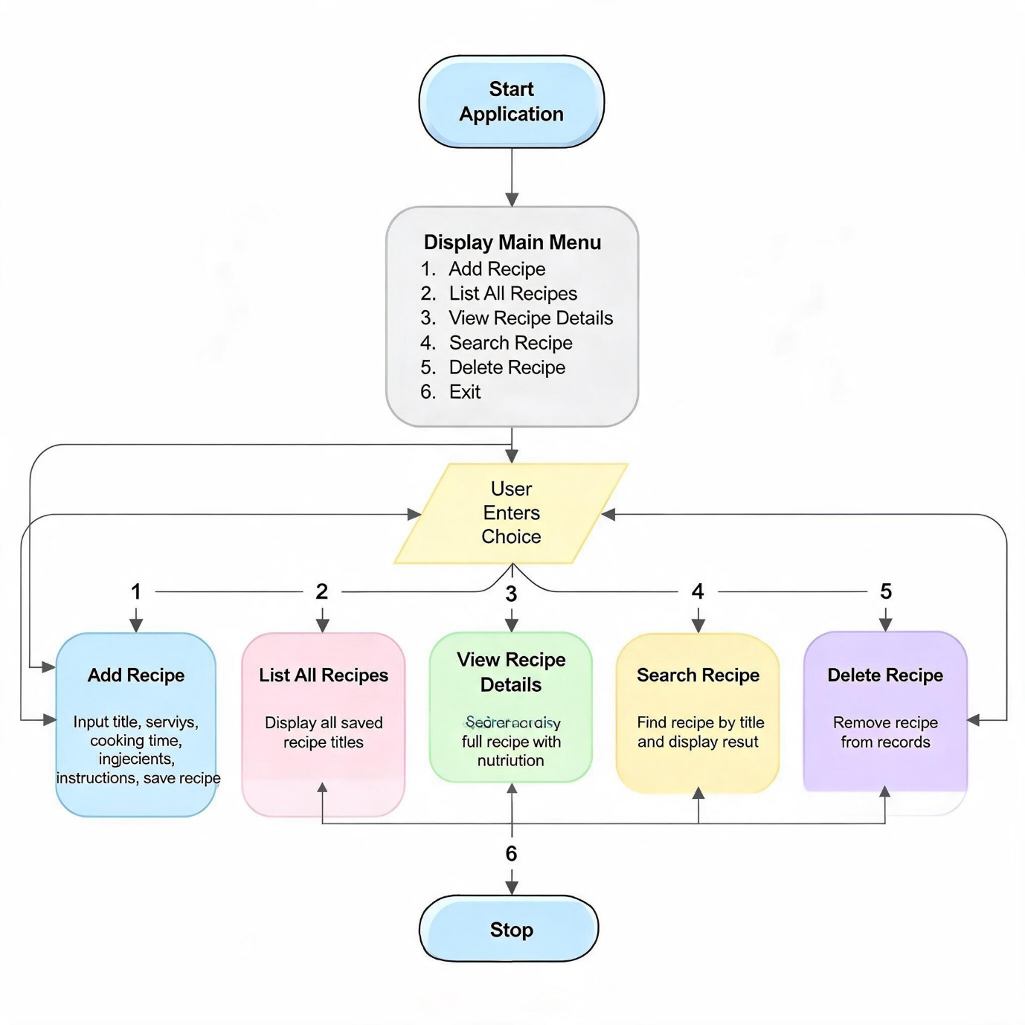

6. Implementation

6.1 Source code

from typing import List, Dict, Optional

class Ingredient:
"""Represents a single ingredient with nutrition info."""

def __init__(
self,
name: str,
quantity: float,
unit: str,
calories: float = 0.0,
protein: float = 0.0,
fat: float = 0.0,
carbs: float = 0.0
):
self.name = name
self.quantity = quantity
self.unit = unit
self.calories = calories
self.protein = protein
self.fat = fat
self.carbs = carbs

def __str__(self) -> str:
"""Human-readable string for ingredient."""
return (
f"{self.quantity} {self.unit} of {self.name} "
f"(C: {self.calories} kcal, P: {self.protein}g, F: {self.fat}g, Cb: {self.carbs}g)"
)

class Recipe:
"""Represents a recipe with ingredients, instructions, and nutrition."""

def __init__(self, title: str, servings: int, cooking_time_minutes: int = 0):
self.title = title
self.servings = servings
self.cooking_time_minutes = cooking_time_minutes
self.ingredients: List[Ingredient] = []
self.instructions: List[str] = []

def add_ingredient(self, ingredient: Ingredient) -> None:
"""Add an ingredient to the recipe."""
self.ingredients.append(ingredient)

def add_instruction(self, step: str) -> None:
"""Add one instruction step."""
self.instructions.append(step)

# Nutrition calculations
def get_total_nutrition(self) -> Dict[str, float]:
"""Sum nutrition for all ingredients."""
total = {
"calories": 0.0,
"protein": 0.0,
"fat": 0.0,
"carbs": 0.0
}
for ing in self.ingredients:
total["calories"] += ing.calories
total["protein"] += ing.protein
total["fat"] += ing.fat
total["carbs"] += ing.carbs
return total

def get_nutrition_per_serving(self) -> Dict[str, float]:
"""Nutrition per single serving."""
total = self.get_total_nutrition()
if self.servings <= 0:
return total
per_serving = {
"calories": total["calories"] / self.servings,
"protein": total["protein"] / self.servings,
"fat": total["fat"] / self.servings,
"carbs": total["carbs"] / self.servings,
}
return per_serving

def display(self) -> None:
"""Print full recipe with nutrition."""
print("\n" + "=" * 60)
print(f"Recipe: {self.title}")
print(f"Servings: {self.servings} | Cooking time: {self.cooking_time_minutes} min")
print("=" * 60)

print("\nIngredients:")
print("-" * 60)
if not self.ingredients:
print(" No ingredients added.")
else:
for i, ing in enumerate(self.ingredients, start=1):
print(f" {i}. {ing}")

print("\nInstructions:")
print("-" * 60)
if not self.instructions:
print(" No instructions added.")
else:
for i, step in enumerate(self.instructions, start=1):
print(f" {i}. {step}")

total = self.get_total_nutrition()
per_serving = self.get_nutrition_per_serving()

print("\nNutrition (Total for all servings):")
print("-" * 60)
print(f" Calories: {total['calories']:.1f} kcal")
print(f" Protein: {total['protein']:.1f} g")
print(f" Fat: {total['fat']:.1f} g")
print(f" Carbs: {total['carbs']:.1f} g")

print("\nNutrition (Per serving):")
print("-" * 60)
print(f" Calories: {per_serving['calories']:.1f} kcal")
print(f" Protein: {per_serving['protein']:.1f} g")
print(f" Fat: {per_serving['fat']:.1f} g")
print(f" Carbs: {per_serving['carbs']:.1f} g")

print("=" * 60 + "\n")

class RecipeManager:
"""Manages a collection of recipes."""

def __init__(self):
self.recipes: Dict[str, Recipe] = {} # key: recipe title (lowercase)

def add_recipe(self, recipe: Recipe) -> None:
"""Add a recipe if title not already present."""
key = recipe.title.lower()
if key in self.recipes:
print(f"Recipe '{recipe.title}' already exists!")
else:
self.recipes[key] = recipe
print(f"Recipe '{recipe.title}' added successfully.")

def find_recipe(self, title: str) -> Optional[Recipe]:
"""Find recipe by title (case-insensitive)."""
return self.recipes.get(title.lower())

def list_all_recipes(self) -> None:
"""List all recipe titles."""
print("\nAll recipes:")
print("-" * 40)
if not self.recipes:
print(" No recipes added yet.")
else:
for title in self.recipes.keys():
print(f" - {title}")
print()

def delete_recipe(self, title: str) -> None:
"""Delete a recipe by title."""
key = title.lower()
if key in self.recipes:
del self.recipes[key]
print(f"Recipe '{title}' deleted.")
else:
print(f"Recipe '{title}' not found.")

def get_ingredient_from_user() -> Ingredient:
"""Prompt user to enter one ingredient with nutrition."""
print("\nEnter ingredient details:")
name = input(" Name: ").strip()
quantity = float(input(" Quantity (e.g. 200): "))
unit = input(" Unit (e.g. g, ml, pcs): ").strip()
calories = float(input(" Calories (kcal, per this quantity): ") or "0")
protein = float(input(" Protein (g): ") or "0")
fat = float(input(" Fat (g): ") or "0")
carbs = float(input(" Carbs (g): ") or "0")

return Ingredient(name, quantity, unit, calories, protein, fat, carbs)

def get_recipe_from_user(manager: RecipeManager) -> None:
"""Guide user to create a new recipe interactively."""
print("\n--- Add New Recipe ---")

title = input("Recipe title: ").strip()
if not title:
print("Title cannot be empty.")
return

servings = int(input("Number of servings: ") or "1")
cooking_time = int(input("Cooking time (minutes, optional): ") or "0")

recipe = Recipe(title, servings, cooking_time)

print("\nEnter ingredients (type 'done' for name when finished):")
while True:
name_check = input(" Ingredient name (or 'done'): ").strip()
if name_check.lower() == "done":
break
# Re-use input by forcing a mini flow
quantity = float(input(" Quantity: ") or "0")
unit = input(" Unit: ").strip()
calories = float(input(" Calories (kcal): ") or "0")
protein = float(input(" Protein (g): ") or "0")
fat = float(input(" Fat (g): ") or "0")
carbs = float(input(" Carbs (g): ") or "0")

ing = Ingredient(name_check, quantity, unit, calories, protein, fat, carbs)
recipe.add_ingredient(ing)

print("\nEnter instruction steps (type 'done' when finished):")
step_num = 1
while True:
step = input(f" Step {step_num}: ").strip()
if step.lower() == "done":
break
recipe.add_instruction(step)
step_num += 1

manager.add_recipe(recipe)

def main_menu():
"""Main interactive menu for the recipe manager."""
manager = RecipeManager()

print("\n" + "=" * 60)
print("Welcome to the Recipe Manager System")
print("Manage recipes, ingredients, instructions, and nutrition.")
print("=" * 60)

while True:
print("\nMenu:")
print("1. Add new recipe")
print("2. List all recipes")
print("3. View recipe details + nutrition")
print("4. Search recipe by title")
print("5. Delete recipe")
print("6. Exit")

choice = input("Enter choice (1-6): ").strip()

if choice == "1":
get_recipe_from_user(manager)

elif choice == "2":
manager.list_all_recipes()

elif choice == "3":
manager.list_all_recipes()
title = input("Enter recipe title to view: ").strip()
recipe = manager.find_recipe(title)
if recipe:
recipe.display()
else:
print(f"Recipe '{title}' not found.")

elif choice == "4":
title = input("Enter recipe title to search: ").strip()
recipe = manager.find_recipe(title)
if recipe:
print(f"\nRecipe found: {recipe.title}")
recipe.display()
else:
print(f"Recipe '{title}' not found.")

elif choice == "5":
title = input("Enter recipe title to delete: ").strip()
manager.delete_recipe(title)

elif choice == "6":
print("\nExiting Recipe Manager. Goodbye!")
break

else:
print("Invalid choice. Please enter 1-6.")

if __name__ == "__main__":
main_menu()

7. OUTPUT SCREENS

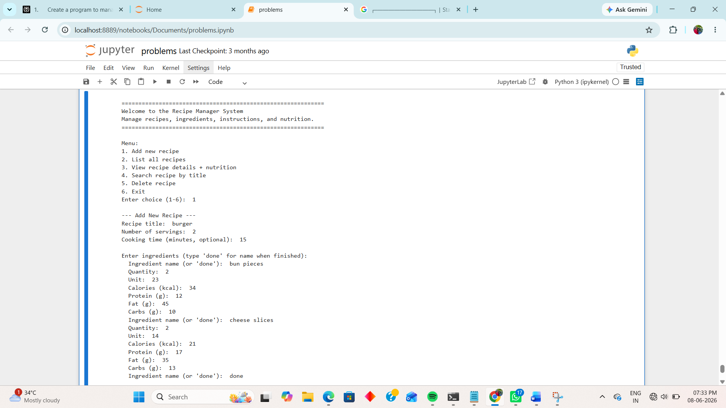

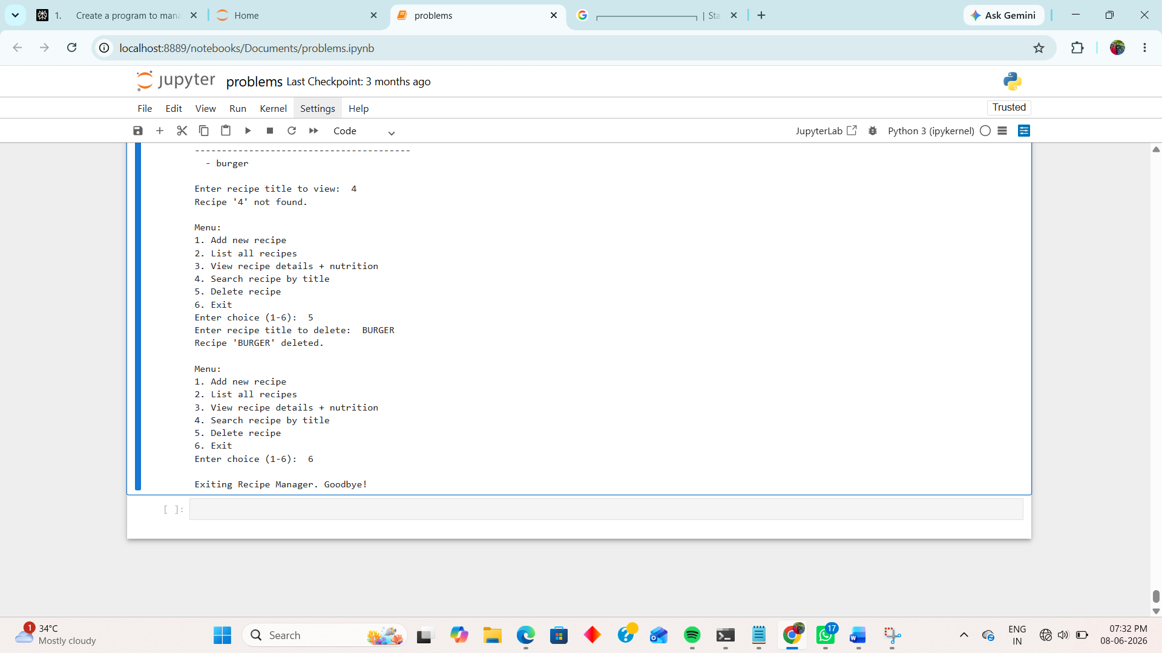

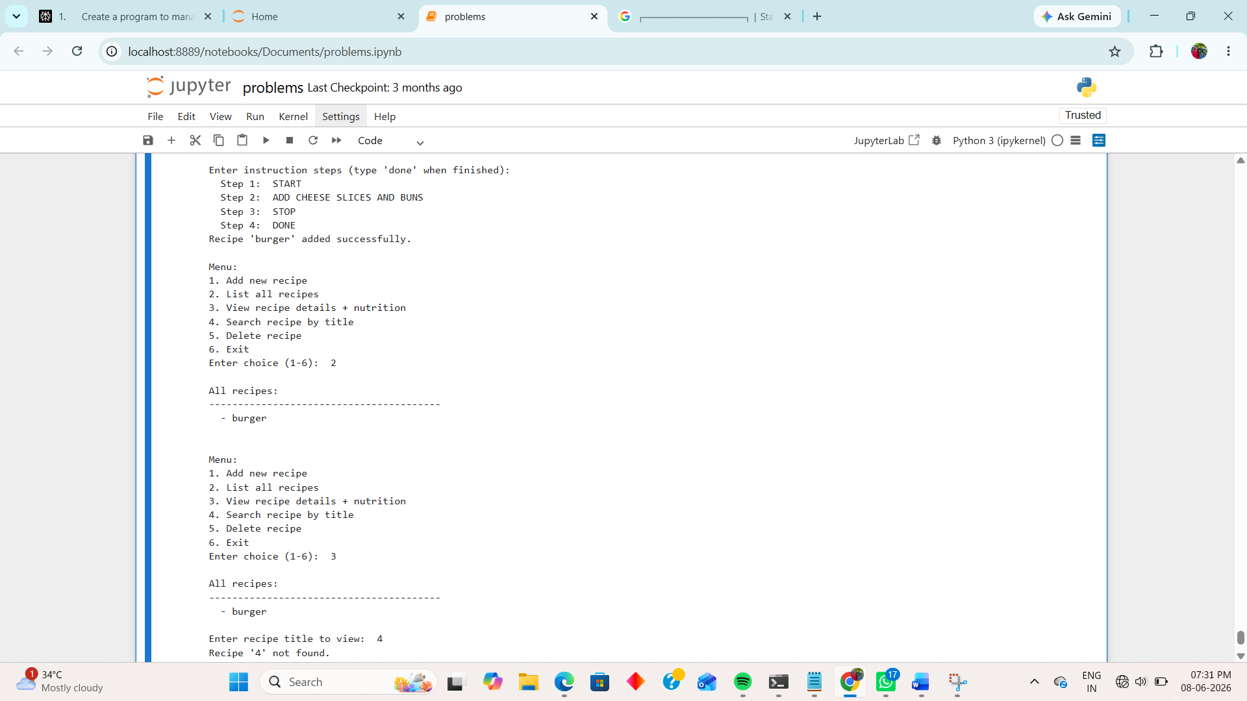

8.CONCLUSION

This Python Recipe Management System is a simple and useful application that organizes recipes, ingredients, instructions, and nutrition details in one place. It shows how object-oriented programming can solve a real-life problem in a clear and structured way.

9. FUTURE SCOPE

This project can be improved by adding file storage, a graphical user interface, and automatic nutrition API integration.

10.REFERENCES
- Reema Thareja, Python Programming Using Problem Solving Approach, Oxford University Press.
- Guido van Rossum, Python Tutorial, Python Software Foundation.
- GeeksforGeeks – Python Programming Language Tutorials.
- Jupyter notebook for code execution

